OS SKILL 1,2
1)
Step 1: Open PowerShell as Administrator
Press the Windows key.
Search for PowerShell.
Right-click on Windows PowerShell.
Select Run as Administrator.
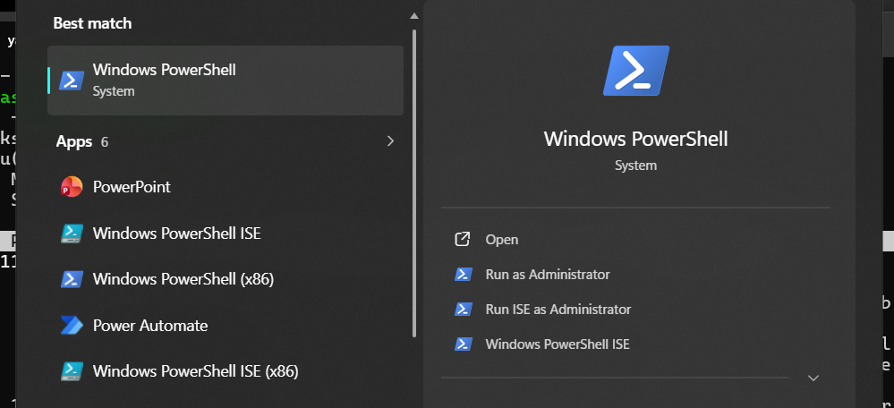
Step 2: Install WSL
In the Administrator PowerShell terminal, enter the following command:
wsl --install
Press Enter and wait for the installation to complete.
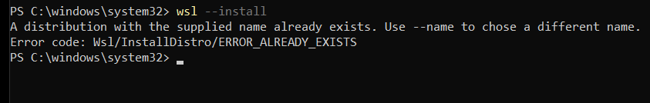
Step 3: Restart the Computer
After the WSL installation is completed, restart the computer when prompted.
Step 4: Complete Ubuntu Setup
After restarting the computer:

Ubuntu may open automatically.
If it does not open, search for Ubuntu in the Start menu.
Wait for the Ubuntu installation to finish.
Enter a Linux username when prompted.
Example:
Enter new UNIX username: yasasri
Step 5: Create a Password
Ubuntu will then ask you to create a password.
Enter the password and then enter it again for confirmation.
Example:
New password: ****
Retype new password: ****
Note: The password will not be displayed while typing in the Linux terminal.
Step 6: Update Ubuntu
After completing the Ubuntu setup, update the package information using:
sudo apt update
Enter the password if prompted and wait for the update to complete.
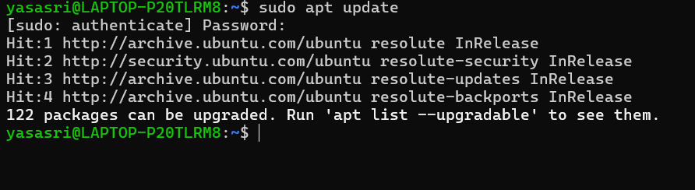
Step 7: Install GCC (C Compiler)
Install the GCC compiler and required development tools using:
sudo apt install build-essential
When prompted with:
Continue? [Y/n]
enter:
y
and press Enter.
Wait for the installation to complete.
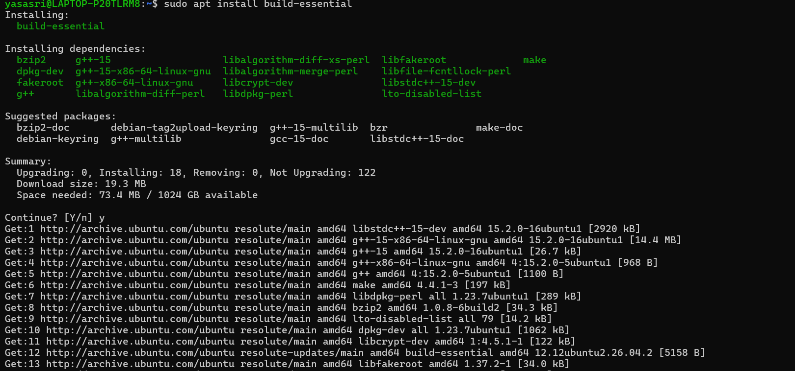
Step 8: Verify the GCC Installation
To check whether GCC has been installed successfully, enter:
gcc --version
If GCC is installed correctly, the terminal will display the installed GCC version
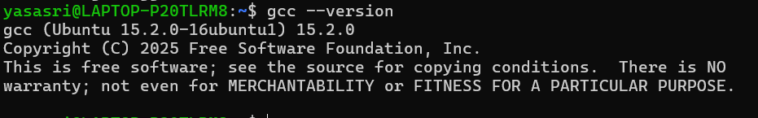

GITHUB Repository:
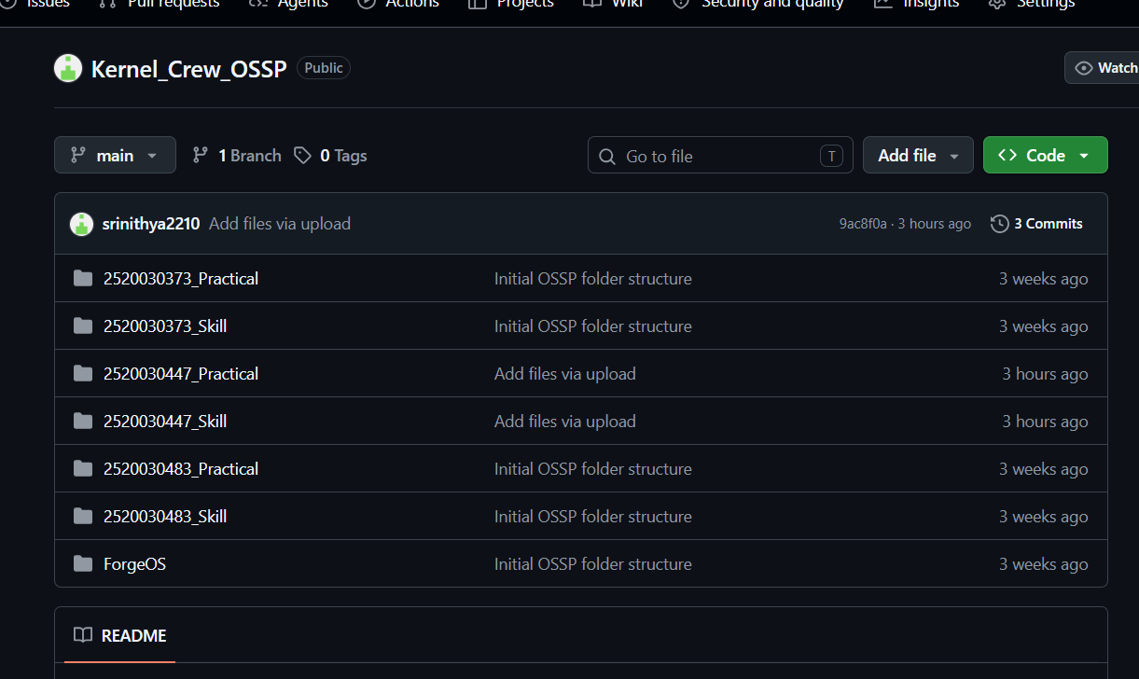

fork()
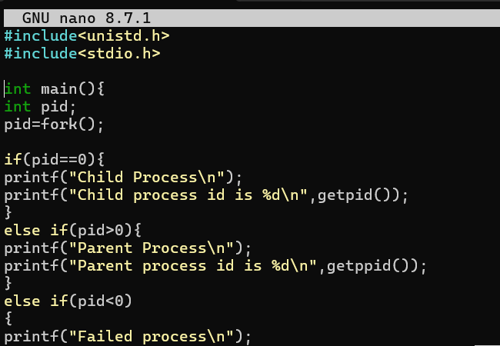

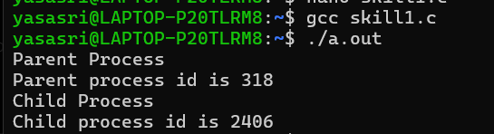

exec()
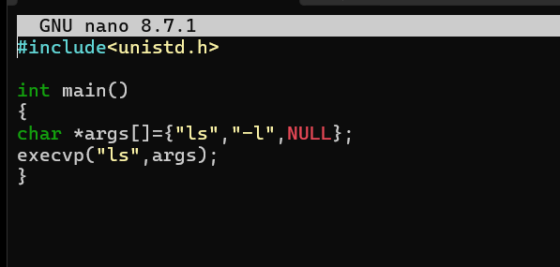
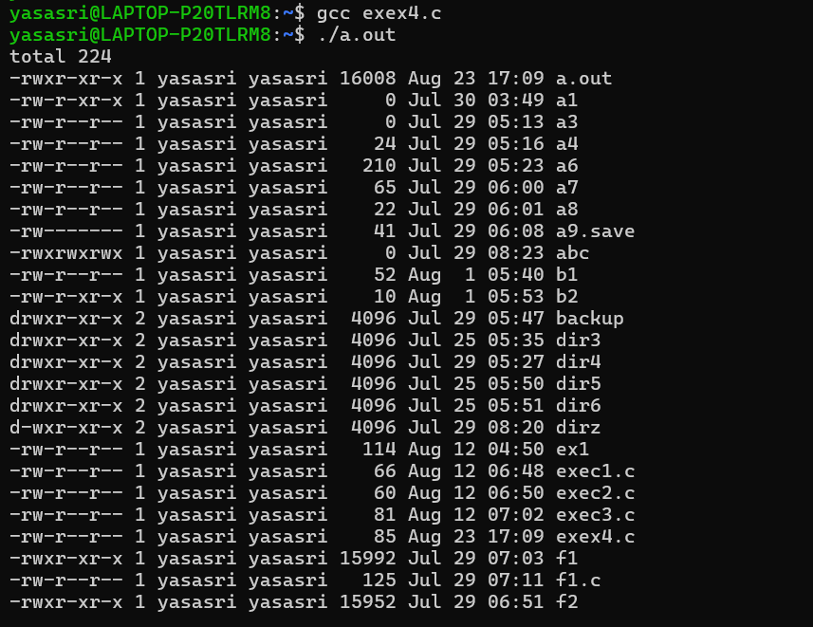

2)
